**Request for Proposals**

**Solicitation No: RFP TEPS-2022-003**

**Title: Kaila Market**

**Issue Date: 6 March 2022**

**Closing Date: 23 March 2022**

**Questions Due: 9 March 2022**

**Closing Time: 15:00hr (3:00pm) Khartoum, Sudan**

**Subject: USAID Contract No. AID-667-C-14-00001**

**Toward Enduring Peace in Sudan (TEPS)**

DT Global, the implementer of the Toward Enduring Peace in Sudan (TEPS) under USAID Contract No. AID-667-C-14-00001, invites proposals for construction services as described in Attachment I “Statement of Work

The period of performance for this activity anticipates commencing on 2 April 2022 and ending 30 July 2022. The issuance of a subcontract is subject to availability of funds, successful negotiation of the subcontract terms and budget, and reception of USAID’s Contracting Officer subcontract consent, if required. The Contract resulting from this award is envisioned to be a Firm Fixed Price (FFP) subcontract.

DT Global encourages your organization to indicate its interest in this procurement by submitting a proposal in accordance with the instructions in Attachment II “Instructions to Offerors”. Proposals will be evaluated based on the evaluation criteria established in Attachment III of this solicitation. An award will be made to the Offeror whose proposal represents the best value to the project after evaluation in accordance with the criteria stated in the solicitation.

To be considered under the solicitation process, the Offeror should submit a complete proposal by the means indicated herein no later than the closing date and time indicated above. Offerors should ensure that the proposals are well written, easy to read and follow, and contain only the requested information.

Proposals can be submitted **electronically** via email to:

TEPS Procurement Team

Email: [procurements@aisudan.com](mailto:procurements@aisudan.com)

The solicitation number above must also be mentioned in the subject of the email.

All questions relating to this solicitation must be submitted electronically via email to:

Procurement Team at [procurements@aisudan.com](mailto:procurements@aisudan.com), no later than 9 March 2022 at 15:00hrs (3 pm) Khartoum, Sudan time. Unless otherwise notified by an amendment to this RFP, no questions will be accepted after this date. No questions/clarifications will be entertained if received by means other than the specified email address. The solicitation number should be stated in the subject. If you are planning to submit a proposal, it is imperative to confirm receipt of this solicitation by email to [procurements@aisudan.com](mailto:procurements@aisudan.com) in order to be included on the solicitation mailing list to receive answers to questions and any future amendment(s).

Proposals must be submitted separately via two different emails. The first email shall include the technical proposal as an attachment and should be named “Technical Proposal” and the second email shall include the cost/business proposal and should be named “Business Proposal.”

Attachments:

* Attachment I Statement of Work
* Attachment II Instructions to Offerors
* Attachment III Evaluation Criteria
* Attachment IV Prime Contract Flow-Down Clauses

Sincerely,

Mohamed Abdalla Hassan

Procurement Specialist, Toward Enduring Peace in Sudan

DT Global

**ATTACHMENT I**

**STATEMENT OF WORK**

**Purpose:**

DT Global seeks to identify a Construction Company to provide construction services for the Kaila Market in Darfur. The purpose of this activity is to create a conducive and attractive voluntary returning environment for returnees. This will be accomplished through constructing a peace market in Kaila village, which will help in promoting peace between the returners and the herdsmen in El Salam, South Darfur.

**Background:** DT Global is currently implementing the USAID-funded TEPS project in Sudan. In order to implement its project objectives, DT Global maintains the following offices:

|  |  |
| --- | --- |
| **Office Location** | **Office Region** |
| Khartoum | TEPS Main Office |
| Damazine | Blue Nile |
| El Fula | West Kordofan |
| Kadugli | South Kordofan |
| El Fasher | Darfur States |
| Kassala | Eastern Sudan |

**Project Overview and** **Project Requirements**

Kaila village is located in El Salam locality, South Darfur state. The village began to witness a large influx of returnees from IDP camps of differing ethnic groups in recent years. Currently the nearest market to the village of Kaila is in the neighboring community of Elmalam. Elmalam is more than 15km away from Kaila, and the local market in this community is only open one day per week. Due to the distance between Kaila and Elmalam, residents are subject to security incidents in their movement to-and-from the market, including killing, harassment, and other forms of abuse (particularly targeting women and youth) at the hands of different armed groups and militias. This has limited the appeal of returning to Kaila IDPs.

The purpose of this activity is to create a conducive and attractive voluntary returning environment for returnees. This will be accomplished through constructing a peace market in Kaila village, which will help in promoting peace between the returners and the herdsmen in El Salam, South Darfur.

**Scope of Work:**

In order to contribute to creating a conducive and attractive voluntary return environment in the community, TEPS will be establishing a “peace market” in Kaila village, which will reduce the risks to community members. Additionally, the market will help in promoting peace between those returning to the community and local herdsmen through daily meetings. Included with the project is the construction of 18 shops, and the construction of two blocks of latrines for public use. The detailed specification can be found below:

**Table 1: Bill of Quantities (BoQ) Structural Elements (LOT 1 – Market) Al Malam Shops**

**Establishment of Services and Facilities in and around Al Malam Village, South Darfur State**

**IMPORTANT NOTES:** By populating and pricing the BOQ items below, the Tenderer certifies and confirms his complete acquaintance with and understanding of the Site Conditions, Work Scope, Designs, Specifications, BoQ Preamble, the Conditions of Contract, the prevailing market conditions and the local laws and regulations. The Price Sufficiency Clause in the Conditions of Contract shall apply.

All and any other items not priced hereunder shall be deemed part of the Unit Rate Pricing.

**BOQ for one block of tow shops joint together**

|  |  |  |  |  |  |
| --- | --- | --- | --- | --- | --- |
| **Item** | **Description** | **Unit** | **Qty** | **Unit Price (SDG)** | **Total Cost (SDG)** |
| **1** | **Excavation , Disposal and sand work:** |  |  |  |  |
| **1.1** | Excavate of strip foundation from existing ground level (40cm Width *70cm depth) appropriate depths to be decided on site) including leveling and ramming bottom, free from water and removing surplus excavated materials out of the site to disposal location as directed by the Engineer. | M.L | 24 |  |  |
| **1.2** | Filling and Compaction: Fill with selected fill material, in 15cm successive layers, each layer watered and well-compacted at minimum 95% rate approved by the Engineer for floor or ground | m3 | 6 |  |  |
| **2** | **Masonry work** |  |  |  |  |
| **2.2** | Supply and fix, Filling & constructing strip foundation using stone with cement mortar (1:8 mix ratio) until 15cm above existing ground level | m3 | 8.4 |  |  |
| **3** | **Concrete work:** |  |  |  |  |
| **3.1** | **Reinforced Concrete:** Cast in place ready mix reinforced concrete for grade beam 25*30cm (grade 35N/mm²), 6T12mm bars & 8mm links @ 20cm C/C as per drawings and specifications. Rate shall include steel fabrication and placing, formwork, scaffolding, equipment, labor, concrete mix design, sampling, testing, curing, etc. | m3 | 1.8 |  |  |
| **3.2** | **Reinforced Concrete:** Cast in place ready mix reinforced concrete for tie beam 15*30cm (grade 35N/mm²), 4T12mm bars & 8mm links @ 20cm C/C as per drawings and specifications. Rate shall include steel fabrication and placing, formwork, scaffolding, equipment, labor, concrete mix design, sampling, testing, curing, etc. | m3 | 1 |  |  |
| **3.3** | **Reinforced Concrete:** Cast in position ready mix reinforced concrete for roof beam 18*30cm (grade 35N/mm²), 4T12mm bars & 8mm links @ 20cm C/C as per drawings and specifications. Rate shall include steel fabrication and placing, formwork, scaffolding, equipment, labor, concrete mix design, sampling, testing, curing, etc. To be cast together with roof slab. | m3 | 1.3 |  |  |
| **3.4** | **Reinforced Concrete:** Cast in position ready mix reinforced concrete for roof slab 12cm thick (grade 35N/mm²), using T12mm @ 15 cm C/C as per drawings and specifications. Rate shall include steel bar fabrication and placing, formwork, scaffolding, equipment, labor, concrete mix design, sampling, testing, curing, etc. | m3 | 4.3 |  |  |
| **4** | **Brick work (SSB)** |  |  |  |  |
| **4.1** | Providing well produced stabilized soil bricks | 1000 bricks | 3.2 |  |  |
| **4.2** | Labor cost for construction of Stabilized soil brick wall 29 cm thick with cement mortar, includes parapet, the outside wall face should be fair face, the cost includes scaffolding, equipment, labor, curing, etc. | m2 | 65 |  |  |
| **5** | **Tiling:** |  |  |  |  |
| **5.1** | Providing and Laying ceramic tiles, the cost contains 5cm sand layer and cement mortar (1:8 mix ratio) | m2 | 20 |  |  |
| **6** | **Openings:** |  |  |  |  |
| **6.1** | Steel double door (rolling) type D1; size 2m x 2.2m subjected to site engineer approval | No. | 2 |  |  |
| **7** | **Plaster & painting:** |  |  |  |  |
| **7.1** | **Plaster Work:** Apply cement / sand plaster; 20mm thickness in two layers, 1:8 cement: sand mix finished smooth. Rate to include expanded metal lath when applied on concrete surfaces, working to or at any height, narrow widths and jambs or reveals, sides and soffits of beams, up stands and making good as approved by the engineer, for internal plaster | m2 | 150 |  |  |
| **7.2** | **Painting Work:** Apply, as per drawings and specification, paint on cement / sand plaster complete with abrasion, hair-cracks fiber repairing and cleaning with penetrating sealer, two coats of emulsion painting for internal walls, as approved of the engineer. | m2 | 150 |  |  |
| **7.3** | **Painting Work:** Apply, as per drawings and specification, paint on brick wall, two coats of emulsion painting coats of paint textured or water proof polish for external surface. As approved of the engineer, for external painting. | m2 | 150 |  |  |
| **8** | **Plain concrete:** |  |  |  |  |
| **8.1** | Laying plain concrete 7cm thick for the ground the cost includes scaffolding, equipment, labor, curing, etc. | m2 | 20 |  |  |
| **8.2** | Laying plain concrete grades from 5cm to 3cm thick for the top flour, contains polishing bitumen for water proof and fix 3 drainage pipe the cost includes scaffolding, equipment, labor, curing, etc. | m2 | 20 |  |  |
| **9** | Constructing corrugated zinc sheet 35, open shelter 6*2.2m supported by steel pipe 4*8cm 1mm as pillars and purlins front the shop | m2 | 12 |  |  |
|  | **Total** |  |  |  |  |

|  |
| --- |
| **Cost for 9 block (of 2 shops) = 9 ×Total =** |

**Table 2: Structural Elements (LOT 2) – Latrines Al Malam Shops**

**Establishment of Services and Facilities in and around Al Malam Village, South Darfur State.**

**IMPORTANT NOTES:** By populating and pricing the BOQ items below, the Tenderer certifies and confirms his complete acquaintance with and understanding of the Site Conditions, Work Scope, Designs, Specifications, BoQ Preamble, the Conditions of Contract, the prevailing market conditions and the local laws and regulations. The Price Sufficiency Clause in the Conditions of Contract shall apply.

All and any other items not priced hereunder shall be deemed part of the Unit Rate Pricing.

**BOQ for one block of latrine 3doors:**

|  |  |  |  |  |  |
| --- | --- | --- | --- | --- | --- |
| **Item** | **Description** | **Unit** | **Qty** | **Unit Price (SDG)** | **Total Cost (SDG)** |
| **1** | **Excavation , Disposal and sand work:** |  |  |  |  |
| **1.1** | Excavate strip foundation from existing ground level (approx.40cm depth *50cm; final depths to be decided in consultation with Site Engineer) including leveling and ramming bottom. Foundation is to be free from water and surplus excavated materials must be removed from the site to disposal location as directed by the Site Engineer | M.L | 24 |  |  |
| **1.2** | Excavation of pit latrine 2.5 m diameter and 5m deep | m3 | 25 |  |  |
| **1.3** | Filling and Compaction: Fill with selected fill material, in 15cm successive layers, each layer watered and well-compacted at minimum 95% rate approve by the Site Engineer for floor or ground | m3 | 4 |  |  |
| **2** | **Masonry work** |  |  |  |  |
| **2.1** | Supply and fix, Filling & constructing strip foundation by stone with cement mortar (1:8 mix ration) until 15cm above existing ground level | m3 | 5.6 |  |  |
| **2.2** | Supply and construct fired red brick wall 20cm thick & cement mortar (same mix ratio as 2.1) for pit latrine | m2 | 35 |  |  |
| **3** | **Concrete work:** |  |  |  |  |
| **3.1** | **Reinforced Concrete:** Cast in place ready mix reinforced concrete for grade beam 20*20cm (grade 35N/mm²), 6T12mm bars & 8mm links @ 20cm C/C as per drawings and specifications. Rate shall include steel fabrication and placing, formwork, scaffolding, equipment, labor, concrete mix design, sampling, testing, curing, etc. | m3 | 1 |  |  |
| **3.2** | **Reinforced Concrete:** Cast in place ready mix reinforced concrete for roof beam 14*15cm (grade 35N/mm²), 4T12mm bars & 8mm links @ 20cm C/C as per drawings and specifications. Rate shall include steel fabrication and placing, formwork, scaffolding, equipment, labor, concrete mix design, sampling, testing, curing, etc. To be cast together with roof slab | m3 | 0.3 |  |  |
| **3.3** | Reinforced Concrete for latrine cover 10cm | m3 | 0.5 |  |  |
| **4** | **Brick work (SSB)** |  |  |  |  |
| **4.1** | Providing well produced stabilized soil bricks | 1000 bricks | 1.5 |  |  |
| **4.2** | Labor cost for construction of stabilized soil brick wall 14 cm thick with cement mortar. Work includes parapet, privacy wall, the outside wall face should be fair face. Price includes scaffolding, equipment, labor, curing, etc. | m2 | 60 |  |  |
| **5** | **Tiling:** |  |  |  |  |
| **5.1** | Providing and Laying ceramic tiles, the cost contains 5cm sand layer and cement mortar (1:8 mix ratio) | m2 | 9 |  |  |
| **6** | **Openings:** |  |  |  |  |
| **6.1** | Steel door (type D1; size 80cm x 200m, using rectangular pipes 4cmx8cm and 6cmx3cm. Subject to Site Engineer approval | No. | 3 |  |  |
| **7** | **Plaster & painting:** |  |  |  |  |
| **7.1** | **Plaster Work:** Apply cement / sand plaster; 20mm thickness in two layers, (1:8 cement: sand mix) finished smooth. Rate to include expanded metal lath when applied on concrete surfaces, working to or at any height, narrow widths and jambs or reveals, sides and soffits of beams, up stands and making good as approved by the engineer, for internal plaster | m2 | 80 |  |  |
| **7.2** | **Painting Work:** Apply, as per drawings and specification, paint on cement / sand plaster complete with abrasion, hair-cracks fiber repairing and cleaning with penetrating sealer, two coats of emulsion painting for internal walls, as approved of the engineer. | m2 | 125 |  |  |
| **7.3** | **Painting Work:** Apply, as per drawings and specification, paint on brick wall, two coats of emulsion painting coats of paint textured or water proof polish for external surface. As approved by the Site Engineer, for external painting. | m2 | 125 |  |  |
| **8** | **Plain concrete:** |  |  |  |  |
| **8.1** | Laying plain concrete 7cm thick for the ground the cost includes scaffolding, equipment, labor, curing, etc. | m2 | 20 |  |  |
| **8.2** | Laying plain concrete grades from 5cm to 3cm thick for the top floor, contains polishing bitumen for water proofing and fix 3 drainage pipe the cost includes scaffolding, equipment, labor, curing, etc. | m2 | 9 |  |  |
| **9** | **Seats & Ventilation:** |  |  |  |  |
| **9.1** | Provide and fix eastern seat | pcs | 3 |  |  |
| **9.2** | Provide and fix ventilation pipe PVC 4 inch | pcs | **1** |  |  |
|  | **Total** |  |  |  |  |

|  |
| --- |
| **Cost for 2 block of latrine 3doors = 2 ×Total =** |

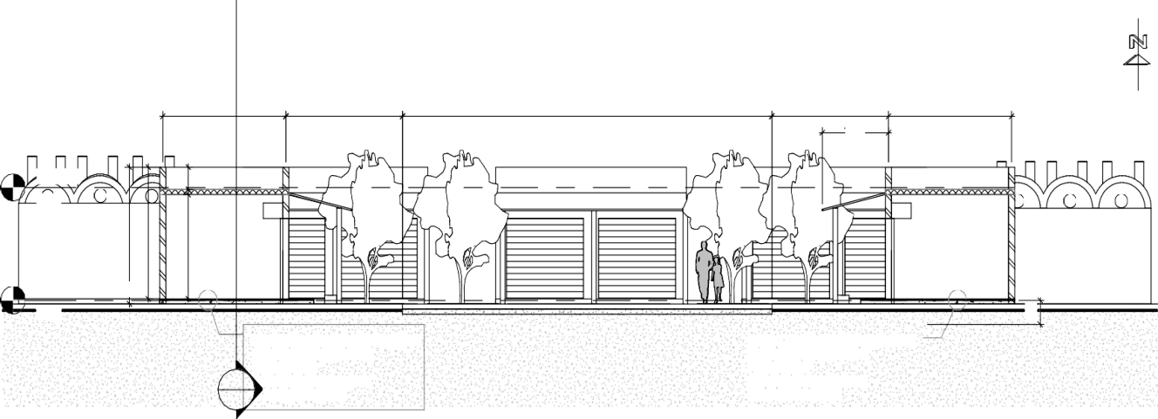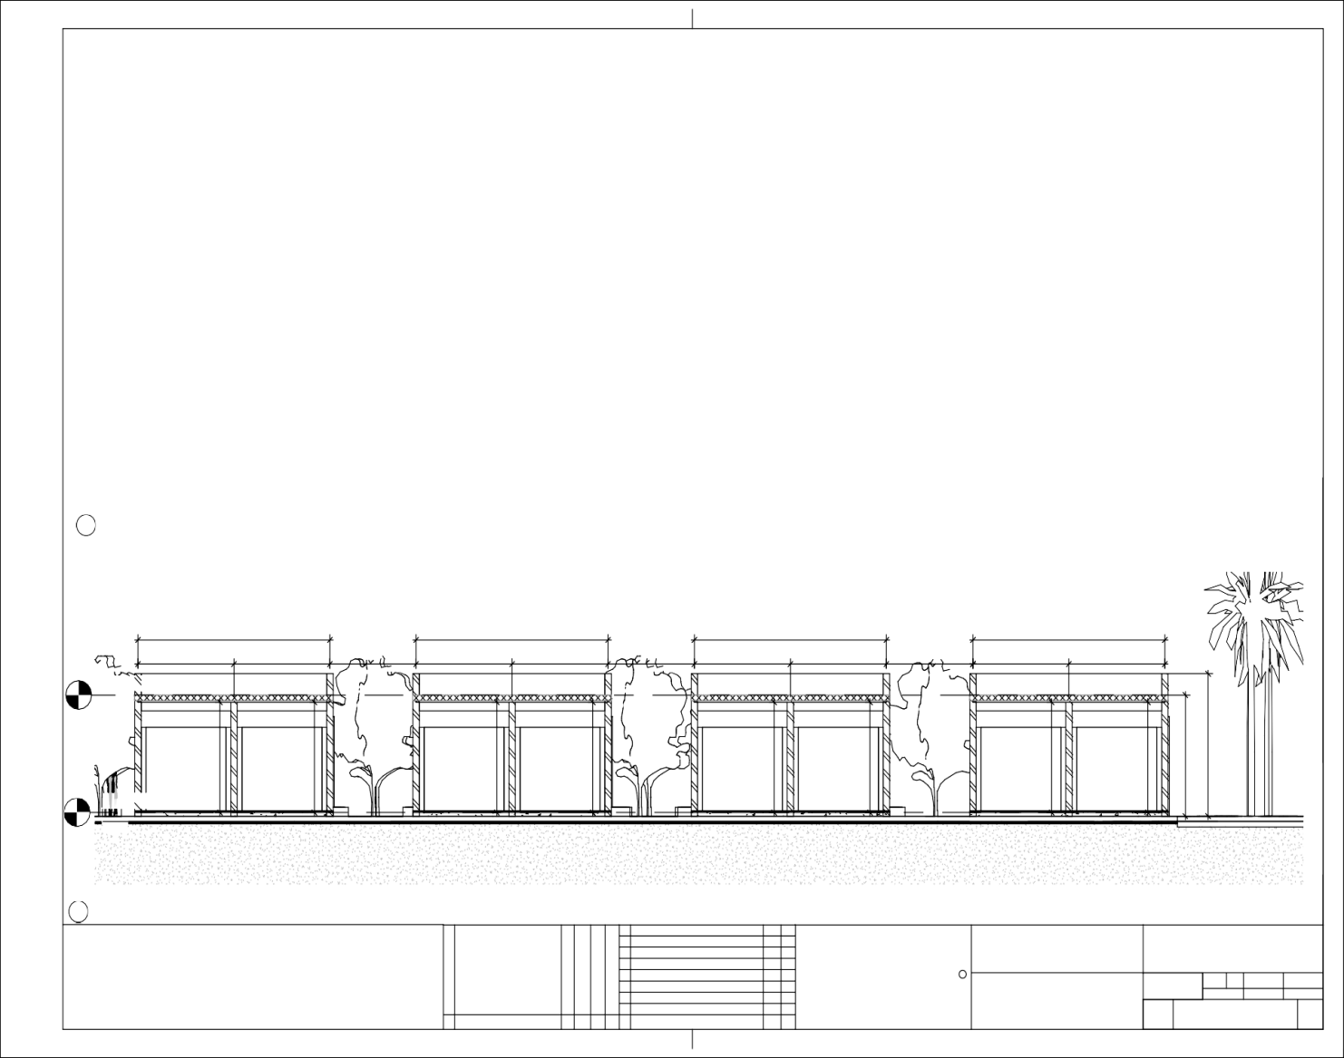

Level 5

3.40

4.00

3.79 12.00

3.79

2.15

0.65

4.00

2

A300

Rev

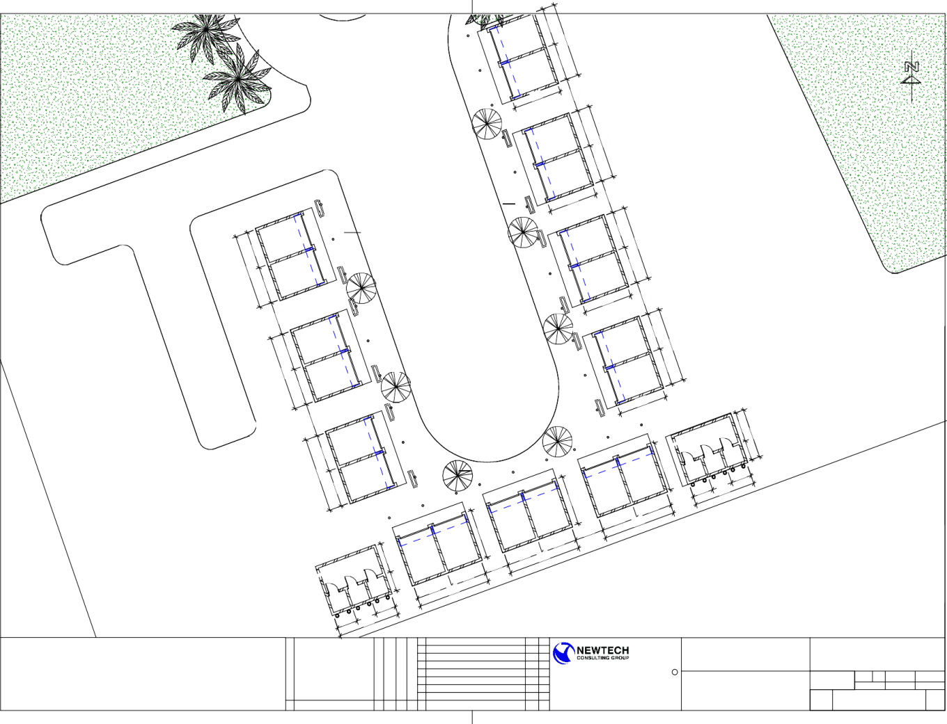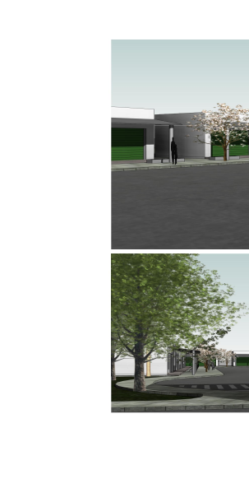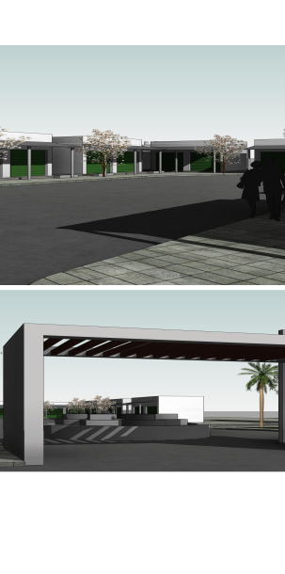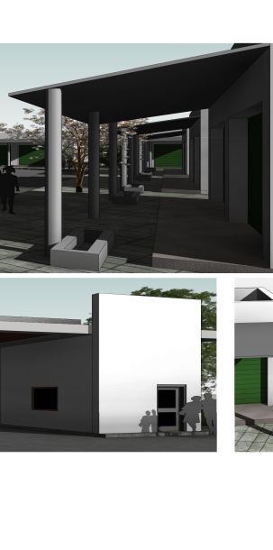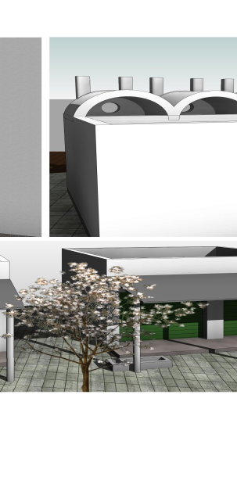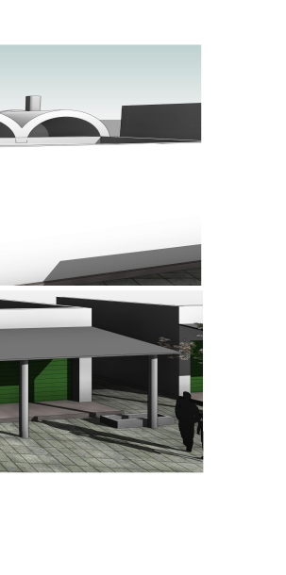

**Attachment II**

**INSTRUCTIONS TO OFFERORS**

**General Instructions**

These Instructions to Offerors will not form part of the offer or of the Subcontract. They are intended solely to aid Offerors in the preparation of their proposals.

* This is a full and open competition open to Sudanese and other developing nation contractors.
* The proposals, and all corresponding documents related to the proposal must be written in the English language unless otherwise explicitly allowed.
* No costs incurred by the Offerors in preparing and submitting the proposal are reimbursable by DT Global. All such costs will be at the Offeror’s expense.
* Proposals and all cost and price figures must be presented in SDG. All prices should be net of Host Country VAT and customs duties. The services provided under this contract are funded by the U.S. Government and shall be exempt from Host Country taxes, import and other fees, as stipulated in the bilateral agreement between the U.S. Government and Government of Sudan. The subcontractor shall obtain prior written approval by DT Global before making any VAT payments. Awards and payments made to Sudan firms will be in local currency.
* The Offeror must state in its Proposal the validity period of its offer. The minimum offer acceptance period for this RFP is **60 days** after closing date of the RFP. Offers with a shorter acceptance period will be rejected. This RFP in no way obligates DT Global to award a subcontract.
* Responsibility Determination: Award shall only be made to “responsible” prospective Offerors. To enable DT Global to make this determination, the Offeror must briefly describe in the Attachment Section of the proposal that it:
* has adequate financial resources including appropriate insurance coverage to perform the work stated herein, or the ability to obtain them;
* is able to comply with the required or proposed delivery or performance schedule, taking into consideration all existing commercial and governmental business commitments;
* has a satisfactory performance record;
* has a satisfactory record of integrity and business ethics;
* has the necessary technical capacity, equipment and facilities, or the ability to obtain them; and
* is otherwise qualified and eligible to receive an award under applicable laws and regulations.
* Eligibility of Firms – Source /Nationality: The authorized geographic code for the source and nationality of the goods, services, and suppliers under the Geocode 937. 937 requires that goods and services be acquired from the United States, cooperating country, and developing countries other than advanced developing countries but excluding any country that is a prohibited source. A full discussion of the source and nationality requirements maybe found at 22 CFR 228. Offerors whose proposals fail to meet the nationality requirements will be considered non-responsive.
* NDAA Section 889 Compliance. Section 889 of John S. McCain National Defense Authorization Act for Fiscal Year 2019 (NDAA) prohibits the U.S. Government and its contractors from (1) procuring or obtaining any equipment, system, or services that uses covered telecommunications equipment or services and (2) enter into a contract (or extend or renew a contract) with an entity that uses any equipment, system, or service that uses covered telecommunications equipment or services. A full discussion of the prohibitions can be found at FAR 52.204-25. To be eligible for award the offeror must complete and sign the representation in Attachment IV.
* In addition to the above and to comply with the Sudan local laws, Offerors must be licensed and authorized to conduct business in Sudan.
* Late Offers: Offerors are wholly responsible for ensuring that their offers are received in accordance with the instructions stated herein. DT Global reserves the right to reject any offer not submitted by the indicated deadline, even if it was late as a result of circumstances beyond the Offeror's control.
* Modification/Withdrawal of Offers: Offerors have the right to withdraw, modify or correct their offer after such time as it has been emailed to DT Global; at the email address stated above and provided that the request is made before the RFP closing date.
* Disposition of Proposals: Proposals submitted in response to this RFP will not be returned. Reasonable efforts will be made to ensure confidentiality of both Business and Technical Proposals received from all Offerors. This RFP does not seek information of a highly proprietary nature but if such information is included in the Offeror’s proposal, the Offeror must alert DT Global and must annotate the material by marking it “Confidential and Proprietary” so that these sections can be treated appropriately.
* Regardless of the method used in the submission of the proposal, the Technical Proposal and Business Proposal must be kept separate from each other. Technical Proposals **must not** make reference to cost or pricing data in order that the technical evaluation may be made strictly on the basis of technical merit.
* Clarification and Amendment to the RFP:
  + Any question raised regarding this solicitation should be received no later 3 pm Sudan local time on March 9 2022. All questions must be **in writing,** emailed to the email address specified in the cover letter. No questions/clarifications will be entertained if they are received by means other than the aforementioned email address. The solicitation number should be stated in the subject line. Responses to questions received will be compiled and emailed to potential Offerors.
* If Offeror intends to submit a proposal in response to this solicitation and wishes to receive any updates thereto, Offeror is encouraged to confirm receipt of this solicitation by email to the email address specified in the cover memo.
* Offeror’s email message should state in the subject the solicitation number. Also, the email should include the name of your organization, the name of contact person, email address and telephone number.
* DT Global anticipates that discussions with Offerors will be conducted; however, DT Global reserves the right to make award without discussions. Therefore, it is strongly recommended that Offerors present their best offer as their initial submission.
* DT Globalmay waive informalities and minor irregularities in proposals received.

**Submission of Proposal:**

* Proposals must be submitted in an electronic format as an email attachment, sent to the email address specified in the cover letter, no later than the date and time specified in the cover letter.
* The email should state the solicitation number in the subject line.
* The file attachment should be in a format that can be opened by one of the following applications: PDF, MSWord, MSExcel, MSPowerPoint. The submission of attachments in any other format may result in disqualifying the offer.
* Please note that the DT Global email server has a limitation of 20MB for the total attachments per single email. It is strongly recommended that the size of ALL attachments per a single email be less than 20MB.
* The technical proposal and business proposals should be submitted in two separate emails. The first should be named “Technical” and the second is named “Cost/Business.” If the submission will be through several emails, then the emails should be sequentially numbered indicating the total number of emails that will be submitted (example 1/4, 2/4, 3/4 and 4/4).

**DUNS Number:**

* The Data Universal Numbering System (DUNS) is a means of identifying business entities on a location-specific basis. https://fedgov.dnb.com/webform/CCRSearch.do?val=1
* Complete a search for your exact, legal company name.
* If you do not currently have a registration, click [Request a New DUNS Number]
* Complete information on your Company name. This information should match your local government registration.
* Complete information on your physical address (and mailing if different)
* Complete information on your organization. Your point of contact should be the same as in your local registration.
* Click [submit request]. A page confirming your submission will appear. Take a screenshot of this confirmation and send it to your MSI POC.
* A representative will confirm your DUNS number when complete. If you do not hear in one week, send an e-mail to ccrhelp@dnb.com, including your Company Name, Physical Address, and Country.
* على كل المتقدمين للتعاقد مع وكالة المعونه الامريكيه و وكلائها او معاقديها و في حالة تجاوز قيمة التعاقد مبلغ 30,000 دولار امريكي ان يتقدموا بطلبات للتسجيل و الحصول على الدنس نمبرو ذلك لتسجيل بياناتهم و انشطتهم و موقع عملهم و هو اجراء روتيني من متطلبات التحقق من المتعاقدين و المتعاونين الجدد.

**Procurement Ethics**

Neither payment nor preference shall be made by either the Offeror, or by any TEPS staff member, to affect the results of the award. TEPS treats all reports of possible fraud/abuse very seriously. Acts of fraud or corruption will not be tolerated, and TEPS employees and/or subcontractors/grantees/vendors who engage in such activities will face serious consequences. Any such practice constitutes an unethical, illegal, and corrupt practice and either the Offeror or the TEPS staff may report violations to the ethics and compliance anonymous via email to [ethics@aisudan.com](mailto:ethics@aisudan.com). TEPS ensures anonymity and an unbiased, serious review and treatment of the information provided. Such practice may result in the cancellation of the procurement and disqualification of the Offeror’s participation in this, and all future procurements. Violators will be reported to USAID, and as a result, may be reported to the relevant U.S. government agencies to be included in a Restricted Parties list, preventing them from participating in future U.S. Government business.

**Content of Proposal:**

The proposal shall consist of five (5) sections. 1) The Cover Page-Technical, 2) The Technical Proposal, 3) The Cover Page-Cost, 4) the Cost/Business Proposal; and 5) The Attachments

1. The Cover Page-Technical:

The cover page should be on the Offeror’s letterhead and MUST contain the following information:

• Solicitation Number

• Company’s Name:

• Company’s Address

• Name of Company’s authorized representative

• Telephone No, Cellular Phone #, Email address

• Validity of Proposal

• Signature, Date and time

1. Technical Proposal:

The technical proposal shall describe how the Offeror intends to carry out the statement of work. It will also address the Offeror’s corporate capabilities to carry out the work and the extent to which the Offeror has a demonstrated ability to provide the required services.

The Offeror will also include the resumes of all proposed personnel. The Offeror shall provide information about past performance implementing similar work globally, and most particularly, in Sudan within the last 3 years. Capacity to undertake the technical and administrative backstopping of all interventions described in the Scope of Work. Offeror should also provide detailed description of existing facilities in the Sudan.

The technical proposal should be divided into three sections following the same order of the technical evaluation criteria mentioned in Attachment III. Failure to respond to any section will be the basis for disqualification of the Offeror from further consideration.

1. The Cover Page - Cost/Business:

The cover page should be on the Offeror’s letterhead and MUST contain the following information:

• Solicitation Number

• Company’s Name:

• Company’s Address

• Name of Company’s authorized representative

• Telephone No, Cellular Phone #, Email address

• Total Proposed Price

• Validity of Proposal

• Acceptance of Tax Withholding Statement

* DUNS number (if available) and TIN
* Name and address of Government Audit Agency and name and

phone number of the auditor

• A valid business license or Registration Certificate

* Signature, Date and time

1. The Cost/Business Proposal:

As stated earlier, the cost proposal shall be submitted separately from the technical proposal. The budget will present the cost for performing the work specified in this solicitation.A template is provided for the pricing as Annex 1. At a minimum, the cost proposal will include the following information:

* A detailed cost break-down of the proposed budget to the maximum extent practical using the template provided.
* A detailed and comprehensive budget narrative explaining the basis for the cost estimates.
* Contractor Employee Biographical Data sheet (USAID 1420-17) for each individual presented in the proposal. The Form has to be duly signed by the individual and the Offeror. See Annex 2 for the form AID 1420-17.
* Negotiated Indirect Rate Agreement (NICRA) or other documentation from its cognizant audit agency, if any, stating the most recent provisional indirect cost rates.
* If Offeror does not have a cognizant audit agency, the Offeror must provide audited balance sheets and profit & loss statements for the last two complete years and current year-to-date; and

The most recent two fiscal year pool and base cost compositions along with derived rates, the bases of allocation of these rates and an independent certified audit by a certified accounting firm of these rates.

1. Attachments

This section will include any information or document that was not listed in the above sections and the Offeror finds necessary to include in the proposal. In this section, the Offeror will also include the information that will assist DT Global to determine the Offeror’s responsibility. The following are required documents to be submitted with the proposal:

* Current copy of the business registration (front and back)
* Proof of good standing with the Sudan Revenue Department
* Proof that there are no outstanding tax liabilities with the Sudan Government that could lead to company being unable to provide services as set out in the RFP
* Visa and work permit policy
* Proof of medical insurance coverage for staff
* Completed and signed NDAA Representation Form (see Annex IV)

This solicitation in no way obligates DT Global to award a subcontract, nor does it commit DT Global to pay any costs incurred in preparation and submission of a proposal in response to the RFP. Furthermore, DT Global reserves the right to reject any and all offers if such action is in the best interest of DT Global.

**Instructions for the Preparation of the Cost/Business Proposal**

The subcontract type will be Firm Fixed Price (FFP) Subcontract.

A Firm Fixed Price Subcontract is: An award for the provision of specific services, goods, or deliverables and is not adjusted if the actual costs are higher or lower than the fixed price amount. Offerors are expected to include all costs, direct and indirect, into their total proposed price.

The Offeror must provide a completed budget in the template provided. If an Excel file, it should not be ‘read only’ or ‘protected’ The proposal must include any necessary supporting information to substantiate proposed costs. The Offerors must submit a detailed budget narrative that supports and clarifies item for item the cost estimates proposed in its budget. Narratives for the individual cost items must provide a discussion of any estimated escalation rates where applicable. Estimated costs proposed to exceed ceilings imposed by USAID or Federal procurement policy must be fully explained and justified.

**ATTACHMENT III**

**EVALUATION CRITERIA**

**TECHNICAL PROPOSAL EVALUATION**

Proposals will be evaluated according to the criteria stated herein. The relative importance of each individual criterion is indicated by the number of points assigned thereto. A total of 100 points is the maximum possible technical score for each proposal. The evaluation criteria serve to: (a) identify the significant factors which the Offeror should address in their proposal under each section and (b) set the standard against which all proposals will be evaluated.

**Technical Approach (20 Points):**

Methodology and work schedule. Offerors should prepare a works schedule in which they shall describe a detailed breakdown of activities that will allow TEPS to monitor weekly progress. The Offerors must demonstrate a full understanding of the work that needs to be performed under the SOW, as well as a clear, straightforward approach to achieving the activity objective.

**Capabilities and Experience (40 Points):**

Registration of the company in Sudan should be for more than 7 years. (20 points)

In-country presence and knowledge of Sudan (Registration with Sudanese contractors’ associations) (20 points)

Provision of a list of key equipment. It is anticipated that significant equipment, tools, and material will be required for this project. The contractor should provide a list of equipment, and confirm the availability, as well as the make and model (brand), year of manufacture, the condition (whether functional or non-functional), and ownership (or rental) of each piece of equipment. (10 points)

**Past Performance (40 points)**

Past performance and reference list. Offerors should provide four projects of a similar type (e.g., government and commercial buildings, schools, markets, etc.) for evaluation. Offerors must provide the location and contact details (including phone number and email addresses) for any project listed. TEPS reserves the right to visit any site for inspection to evaluate an Offeror’s technical capability. (20 Points)

Provision of experienced team in this field (list of engineers and skilled workers and their years of experience; please provide documentation of any relevant certificates or training). (20 points)

**COST PROPOSAL EVALUATION**

Evaluation scores are not assigned for cost. The review of the cost proposal shall include cost realism. This process will include a review of the cost portion of the Offeror’s proposal to determine if the overall costs proposed are reasonable and realistic for the work to be performed, if the cost reflects that the Offeror understands the requirements, and if the costs are consistent with the technical part of the proposal. Cost proposals providing more direct funding towards the program instead of administrative costs will be reviewed favorably in the best value determination. Offerors must use the costing template provided as Annex 1.

Evaluation of cost proposals will consider, but not be limited to, the following:

* Cost realism and completeness of cost proposal and supporting documentation.
* Overall cost control evidenced in the proposal such as avoidance of excessive salaries, competitive procurement of subcontracts, excessive cost of management oversight and other costs in excess of reasonable requirements.
* Amount of proposed fee, if any.
* Cost efficiency of proposed Other Direct Costs (ODCs).

Bidders are reminded that DT Global is not obligated to award a negotiated subcontract based on lowest proposed cost or to the bidder with the highest technical evaluation score. DT Global will make award to the bidder whose proposal offers the best value to the TEPS program considering both technical and cost factors. When competing technical proposals are considered essentially equal then cost will become the determining factor.

**ATTACHMENT IV**

**REPRESENTATION REGARDING CERTAIN TELECOMMUNICATIONS AND VIDEO SURVEILLANCE SERVICES OR EQUIPMENT**

**(a) Prohibitions.**

Section 889(a) of the John S. McCain National Defense Authorization Act (NDAA) for Fiscal Year 2019 (Pub. L. 115-232) prohibits the U.S. Government and any of its contractors and subcontractors from procuring or obtaining or extending or renewing a contract to procure or obtain, any equipment, system, or service that uses covered telecommunications equipment or services as a substantial or essential component of any system, or as critical technology as part of any system.

**(b) Definitions:**

*Covered foreign country* means The People’s Republic of China.

*Covered telecommunications equipment or services* means telecommunications equipment produced by Huawei Technologies Company, ZTE Corporation, Hytera Communications Corporation, Hangzhou Hikvision Digital Technology Company, or Dahua Technology Company (or any subsidiary or affiliate of such entities)

*Critical technology* means defense articles or defense services included on the United States Munitions List set forth in the International Traffic in Arms Regulations under subchapter M of chapter I of title 22, Code of Federal Regulations; Items included on the Commerce Control List set forth in Supplement No. 1 to part 774 of the Export Administration Regulations under subchapter C of chapter VII of title 15, Code of Federal Regulations, and controlled- (i) Pursuant to multilateral regimes, including for reasons relating to national security, chemical and biological weapons proliferation, nuclear nonproliferation, or missile technology; or (ii) For reasons relating to regional stability or surreptitious listening; Specially designed and prepared nuclear equipment, parts and components, materials, software, and technology covered by part 810 of title 10, Code of Federal Regulations (relating to assistance to foreign atomic energy activities); Nuclear facilities, equipment, and material covered by part 110 of title 10, Code of Federal Regulations (relating to export and import of nuclear equipment and material); Select agents and toxins covered by part 331 of title 7, Code of Federal Regulations, part 121 of title 9 of such Code, or part 73 of title 42 of such Code; or Emerging and foundational technologies controlled pursuant to section 1758 of the Export Control Reform Act of 2018 (50 U.S.C. 4817).

*Reasonable inquiry* means an inquiry designed to uncover any information in the entity's possession about the identity of the producer or provider of covered telecommunications equipment or services used by the entity that excludes the need to include an internal or third-party audit.

*Substantial or essential component* means any component necessary for the proper function or performance of a piece of equipment, system, or service.

(**c) Representation.**After conducting a reasonable inquirySubcontractor represents that it [ ] will or [ ] will not provide covered telecommunications equipment or services to DT Global in the performance of any contract, subcontract, order, or other contractual instrument resulting from this contract. This representation shall be provided as part of the proposal and resubmitted on an annual basis from the date of award.

**(d) Disclosures.**If the Subcontractor has responded affirmatively to the representation in paragraph (c) of this clause, the Subcontractor shall provide the following additional information to DT Global:

(1) List of all covered telecommunications equipment and services offered or provided (Entity name, brand; model number, such as original equipment manufacturer (OEM) number, manufacturer part number, or wholesaler number; and item description, as applicable);

(2) Explanation of the proposed use of covered telecommunications equipment and services and any factors relevant to determining if such use would be permissible under the prohibition in paragraph (b) of this provision;

**(e) Reporting requirement.**

(1) In the event the Subcontractor identifies covered telecommunications equipment or services used as a substantial or essential component of any system, or as critical technology as part of any system, during contract performance, or the Subcontractor is notified of such by a subcontractor at any tier or by any other source, the Subcontractor shall report the information in paragraph (d)(2) of this clause to DT Global.

(2) The Subcontractor shall report the following information pursuant to paragraph (d)(1) of this clause

                (i) Immediately upon such identification or notification: the contract number; the order number(s), if applicable; supplier name; supplier unique entity identifier (if known); supplier Commercial and Government Entity (CAGE) code (if known); brand; model number (original equipment manufacturer number, manufacturer part number, or wholesaler number); item description; and any readily available information about mitigation actions undertaken or recommended.

                (ii) Within 5 business days of submitting the information in paragraph (d)(2)(i) of this clause: any further available information about mitigation actions undertaken or recommended. In addition, the Subcontractor shall describe the efforts it undertook to prevent use or submission of covered telecommunications equipment or services, and any additional efforts that will be incorporated to prevent future use or submission of covered telecommunications equipment or services.

**(f) 2nd Tier Subcontracts.** The Subcontractor shall insert the substance of this clause, including this paragraph (f), in all 2nd Tier subcontracts and other contractual instruments, including subcontracts for the acquisition of commercial items.

***(g)  SAM Verification.*** The Subcontractor shall regularly review the list of excluded parties in the System for Award Management (SAM) (<https://www.sam.gov>) to identify entities excluded from receiving federal awards for “covered telecommunications equipment or services”.

Contract/Subcontract No.: _________________

Signature: _____________________________

Date: _________________________________

Name: ________________________________

Title/Position: __________________________

Organization: ___________________________

**ATTACHMENT V**

**Prime Contract Flow-Down Clauses**

This Contract will be funded by the U.S. Agency for International Development (USAID) with DT Global implementing this USAID project. Applicable clauses incorporated herein by reference shall have the same force and effect as if they were incorporated in full text. A copy of the full text of each clause may be obtained from http://www.acquisition.gov/far, http://www.usaid.gov/policy/ads/300/aidar.pdf, or from DT Global ’s procurement official. The term "FAR" means Federal Acquisition Regulation. The terms, "Contractor," "Government" and "Contracting Officer" as used in these clauses shall refer to Vendor, DT Global , and DT Global Contract Administrator respectively. In no event shall any provision of this contract or Orders issued against it be construed as allowing the Vendor to appeal directly to or otherwise communicate directly with (USAID) without written consent of DT Global.

**NUMBER TITLE DATE**

|  |  |  |
| --- | --- | --- |
| 52.202-1 | DEFINITIONS | NOV 2013 |
| 52.203-3 | GRATUITIES | APR 1984 |
| 52.203-5 | COVENANT AGAINST CONTINGENT FEES | MAY 2014 |
| 52.203-7 | ANTI-KICKBACK PROCEDURES | MAY 2014 |
| 52.203-8 | CANCELLATION, RESCISSION, AND RECOVERY OF FUNDS FOR ILLEGAL OR IMPROPER ACTIVITY | MAY 2014 |
| 52.203-10 | PRICE OR FEE ADJUSTMENT FOR ILLEGAL OR IMPROPER ACTIVITY | MAY 2014 |
| 52.203-12 | LIMITATION ON PAYMENTS TO INFLUENCE CERTAIN FEDERAL TRANSACTIONS | OCT 2010 |
| 52.203-13 | CONTRACTOR CODE OF BUSINESS ETHICS | OCT 2015 |
|  | AND CONDUCT |  |
| 52.203-17 | CONTRACTOR EMPLOYEE WHISTLEBLOWER RIGHTS AND REQUIREMENT TO INFORM EMPLOYEES OF WHISTELBLOWER RIGHTS | APR 2014 |
| 52.204-2 | SECURITY REQUIREMENTS | AUG 1996 |
| 52.204-4 | PRINTED OR COPIED DOUBLE SIDED ON RECYCLED PAPER | MAY 2011 |
| 52.204-9 | PERSONAL IDENTITY VERIFICATION OF | JAN 2011 |
|  | PERSONNEL |  |
| 52.204-10 | REPORTING EXECUTIVE COMPENSATION AND FIRST-TIER SUBCONTRACT AWARDS | OCT 2018 |
| 52.204-12 | UNIQUE ENTITY IDENTIFIER MAINTENANCE | OCT 2016 |
| 52.204-13 | SYSTEM FOR AWARD MANAGEMENT | OCT 2018 |
| 52.204-14 | SERVICE CONTRACT REPORTING REQUIREMENTS | OCT 2016 |
| 52.209-6 | PROTECTING THE GOVERNMENT’S INTEREST WHEN SUBCONTRACTING WITH CONTRACTORS DEBARRED, SUSPENDED, OR PROPOSED FOR DEBARMENT | OCT 2015 |
| 52.209-9 | UPDATES OF PUBLICLY AVAILABLE INFORMATION REGARDING RESPONSIBILITY MATTERS | OCT 2018 |
| 52.215-2 | AUDIT AND RECORDS—NEGOTIATION | OCT 2010 |
| 52.215-8 | ORDER OF PRECEDENCE—UNIFROM CONTRACT FORMAT | OCT 1997 |
|  |  |  |
|  |  |  |
| 52.215-14 | INTEGRITY OF UNIT PRICES | OCT 2010 |
| 52.215-15 | PENSION ADJUSTMENTS AND ASSET REVERSIONS | OCT 2010 |
| 52.215-18 | REVERSION OR ADJUSTMENT OF PLANS FOR POSTRETIREMENTBENEFITS (PRB) OTHER THAN PENSIONS | JUL 2005 |
| 52.215-19 | NOTIFICATION OF OWNERSHIP CHARGES | OCT 1997 |
| 52.215-23 | LIMITATIONS ON PASS-THROUGH CHARGES | OCT 2009 |
| 52.216-7 | ALLOWABLE COSTS AND PAYMENT | AUG 2018 |
| 52.216-8 | FIXED FEE | JUN 2011 |
| 52.217-8 | OPTION TO EXTEND SERVICES | NOV 1999 |
| 52.222-1 | NOTICE TO THE GOVERNMENT OF LABOR | FEB 1997 |
|  | DISPUTES |  |
| 52.222-2 | PAYMENT FOR OVERTIME PREMIUMS | JUL 1990 |
| 52.222-3 | CONVICT LABOR | JUN 2003 |
| 52.222-4 | CONTRACT WORK HOURS AND SAFETY | MAR 2018 |
|  | STANDARS ACT – OVERTIME COMPENSATION |  |
| 52.222-21 | PROHIBITIONS OF SEGREGATED FACILITIES | APR 2015 |
| 52.222-26 | EQUAL OPPORTUNITY | SEP 2016 |
| 52.222-29 | NOTIFICATION OF VISA DENIAL | APR 2015 |
| 52.222-35 | EQUAL OPPORTUNITY FOR VETERANS | OCT 2015 |
| 52.222-36 | EQUAL OPPORTUNITY FOR WORKERS WITH DISABILITIES | JUL 2014 |
| 52.222-37 | EMPLOYMENT REPORTS ON VETERANS | FEB 2016 |
| 52.222-50 | COMBATING TRAFFICKING IN PERSONS, | JAN 2019 |
| 52.223-5 | POLLUTION PREVENTION AND RIGHT-TO-KNOW | MAY 2011 |
|  | INFORMATION |  |
| 52.223-6 | DRUG-FREE WORKPLACE | MAY 2001 |
| 52.223-10 | WASTE REDUCTION PROGRAM | MAY 2011 |
| 52.223-18 | ENCOURAGING CONTRACTOR POLICIES OF BAN | AUG 2011 |
|  | TEXT MESSAGING WHILE DRIVING |  |
| 52.224-1 | PRIVACY ACT NOTIFICATION | APR 1984 |
| 52.224-2 | PRIVACY ACT | APR 1984 |
| 52.225-1 | BUY AMERICAN ACT-SUPPLIES | MAY 2014 |
| 52.225-13 | RESTRICTIONS ON CERTAIN FOREIGN PURCHASES | JUN 2008 |
| 52.225-14 | INCONSISTENCY BETWEEN ENGLISH VERSION AND TRANSLATION OF CONTRACT | FEB 2000 |
| 52.227-2 | NOTICE AND ASSISTANCE REGARDING PATENT | DEC 2007 |
|  | AND COPYRIGHT INFRINGEMENT |  |
| 52.227-14 | RIGHTS IN DATA - GENERAL | MAY 2014 |
| 52.228-3 | WORKERS’ COMPENSATION INSURANCE (DBA) | JUL 2014 |
| 52.228-7 | INSURANCE LIABILITY TO THIRD PERSONS | MAR 1996 |
|  |  |  |
| 52.229-3 | FEDERAL, STATE, AND LOCAL TAXES | FEB 2013 |
| 52.230-2 | COST ACCOUNTING STANDARDS | OCT 2015 |
| 52.230-3  52.230-4 | DISCLOSURE AND CONSISTENCY OF COST ACCOUNTING PRACTICES  DISCLOSURE AND CONSISTENCY OF COSTS  ACCOUNTING PRACTICES– FOREIGN CONCERNS | OCT 2015  OCT 2015 |
| 52.230-6 | ADMINISTRATION OF COST ACCOUNTING STANDARDS | JUL 2010 |
| 52.232-9 | LIMITATIONS ON WITHHOLDING OF PAYMENTS | APR 1984 |
| 52.232-17 | INTEREST | MAY 2014 |
| 52.232-18 | AVAILABILITY OF FUNDS | APR 1984 |
| 52.232.22 | LIMITATION OF FUNDS | APR 1984 |
| 52.232-23 | ASSIGNMENT OF CLAIMS | MAY 2014 |
| 52.232-25 | PROMPT PAYMENT | JAN 2017 |
| 52.232-25  52.232-33 | ALTERNATE I  PAYMENT BY ELECTRONIC FUNDS TRANSFER – SYSTEM FOR AWARD  MANAGEMENT | JAN 2017  OCT 2018 |
| 52.232-34 | PAYMENT BY ELECTRONIC FUNDS TRANSFER OTHER THAN SYSTEM FOR  AWARD MANAGEMENT | JUL 2013 |
| 52.232-39 | UNENFORCEABILITY OF UNAUTHORIZED OBLIGATIONS | JUN 2013 |
| 52.233-1 | DISPUTES | MAY 2014 |
| 52.233-1 | ALTERNATE I | MAY 2014 |
| 52.233-3 | PROTEST AFTER AWARD ALTERNATE I | SEP 1996 |
| 52.233-4 | APPLICABLE LAW FOR BREACH OF CONTRACT CLAIM | OCT 2004 |
| 52.237-3 | CONTINUITY OF SERVICES | JAN 1991 |
| 52.237-8 | RESTRICTION OF SEVERANCE PAYMENTS TO FOREIGN NATIONALS | AUG 2003 |
| 52.237-9 | WAIVER OF LIMITATION ON SEVERANCE PAYMENTS TO FOREIGN NATIONALS | MAY 2014 |
| 52.239-1 | PRIVACY OR SECURITY SAFEGUARDS | AUG 1996 |
| 52.242-1 | NOTICE OF INTENT TO DISALLOW COSTS | APR 1984 |
| 52.242-3 | PENALTIES FOR UNALLOWABLE COSTS | MAY 2014 |
| 52.242-4 | CERTIFICATION OF FINAL INDIRECT COSTS | JAN 1997 |
| 52.242-13 | BANKRUPTCY | JUL 1995 |
| 52.243-2 | CHANGES ‐ COST‐REIMBURSEMENT (AUG 1987) – ALTERNATE I | APR 1984 |
| 52.243-7 | NOTIFICATION OF CHANGES | JAN 2017 |
| 52.244-2 | SUBCONTRACTS  ALTERNATE I | OCT 2010  JAN 2007 |
| 52.244-5 | COMPETITION IN SUBCONTRACTING | DEC 1996 |
| 52.244-6 | SUBCONTRACTS FOR COMMERCIAL ITEMS | JAN 2019 |
| 52.245-1 | GOVERNMENT PROPERTY | JAN 2017 |
| 52.246-25 | LIMITATION OF LIABILITY – SERVICES | FEB 1997 |
| 52.249-6 | TERMINATION (COST-REIMBURSEMENT) | MAY 2004 |
| 52.249-14 | EXCUSABLE DELAY | APR 1984 |
| 52.253-1 | COMPUTER GENERATED FORMS | JAN 1991 |
|  | **AIDAR 48 CFR Chapter 7** |  |
| 752.202-1 | DEFINITIONS | JAN 1990 |
| 752.204-2 | SECURITY REQUIREMENTS | FEB 1999 |
| 752.209-71 | ORGANIZATIONAL CONFLICTS OF INTEREST | JUN 1993 |
|  | DISCOVERED AFTER AWARD |  |
| 752.211-70 | LANGUAGE AND MEASUREMENT | JUN 1992 |
| 752.219-8 | UTILIZATION OF SMALL BUSINESS CONCERNS AND SMALL DISADVANTAGED  BUSINESS CONCERNS | MAR 2015 |
| 752.229-70 | FEDERAL, STATE, AND LOCAL TAXES | DEC 2014 |
| 752.242-70 | PERIODIC PROGRESS REPORTS | OCT 2007 |
| 752.245-70 | GOVERNMENT PROPERTY – USAID REPORTING | JULY 1997 |
|  | REQUIREMENTS |  |
| 752.7001 | BIOGRAPHICAL DATA | JUL 1997 |
|  |  |  |
| 752.7006 | NOTICES | APR 1984 |
| 752.7008 | USE OF GOVERNMENT FACILITIES OR PERSONNEL | APR 1984 |

**EXECUTIVE ORDER ON TERRORISM FINANCING (AUG 2016)**

The Subcontractor/Recipient is reminded that U.S. Executive Orders and U.S. law prohibits transactions with, and the provision of resources and support to, individuals and organizations associated with terrorism. It is the legal responsibility of the subcontractor/recipient to ensure compliance with these Executive Orders and laws. This provision must be included in all subcontracts/sub-awards issued under this subcontract/agreement.

and laws. This provision must be included in all subcontracts/sub-awards issued under this subcontract/agreement.

**Executive Compensation Certifications (FAR 52.204-10)**

In accordance with Public Law 109-282 and FAR 52.204·10, Reporting Executive Compensation for First-Tier Subcontract Awards (JUL 2020), you are required to provide certain information pertaining to compensation of executives in order to be eligible for this subcontract award. Please answer the following question(s) in connection with this requirement:

1. **Did your organization in the previous tax year have gross income from all sources over USD 300,000?**

Yes  No

**If you answered “No” to question 1 above,** you are exempt from this reporting requirement. Please sign in the spaces indicated below and return this certification to your point of contact at DT Globa. **If you answered “Yes,”** please complete ***Table I*** and answer the following questions:

1. **Did your company receive 80% or more of its annual gross revenues from Federal contracts (and subcontracts), loans, grants (and subgrants), and cooperative agreements in the preceding fiscal year?**

Yes  No

1. **Did your company receive $25,000,000 or more in annual gross revenues from Federal contracts (and subcontract), loans, grants (and subgrants), and cooperative agreements in the preceding fiscal year?**

Yes  No

1. **Does the public NOT have access to information about the compensation of your company's executives through periodic reports filed under 13(a) or l5(d) of the Securities Exchange Act of 1934 (15 U.S.C. 78m(a), 78o(d)) or section 6104 of the Internal Revenue Code of 1986? (To determine if the public has access to the compensation information, see the U.S. Security and Exchange Commission total compensation filing at** [**http://www.sec.gov/answers/execomp.htm**](http://www.sec.gov/answers/execomp.htm)**.)**

Yes  No

If the answers to questions 2, 3 and 4 are all “Yes,” you are required to provide the names and total compensation of each of the five most highly compensated executives in your organization as part of this certification, and on an annual basis for the life of this subcontract. Provide this compensation information in ***Table II*** below. Please note that as required by public law and FAR 52.204-10(b), APL will report this information to the government, and this information will be made public. Further, please note your continuing obligation to immediately notify APL in writing of any changes to previously reported data.

This certification concerns a matter within the jurisdiction of an agency of the United States and the making of a false, fictitious, or fraudulent certification may render the maker subject to prosecution under Section 1001, Title 18, United States Code.

|  |  |
| --- | --- |
| Company |  |
| Signature |  |
| Printed Name |  |
| Title |  |
| Date |  |

**Executive Compensation Certification (FAR 52.204-10)**

**Table I**

|  |  |
| --- | --- |
| Subcontractor DUNS Number |  |
| Subcontractor Parent Company DUNS Number (if applicable) |  |
| Subcontractor Primary Address  *Must Include nine-digit zip code and Congressional district* |  |
| Primary Location for Performance of Subcontract (if different from Primary Address)  *Must Include nine-digit zip code and Congressional District* |  |
| North American Industry Classification System (NAICS) code |  |

**Table II**

|  |  |  |
| --- | --- | --- |
|  | Name | Total Compensation (as defined in FAR 52.204-10(a)) |
| Executive 1 |  |  |
| Executive 2 |  |  |
| Executive 3 |  |  |
| Executive 4 |  |  |
| Executive 5 |  |  |

**Table Ill (For Internal Use Only)**

|  |  |
| --- | --- |
| Subcontract number |  |
| Amount of the subcontract award |  |
| Date of the subcontract award |  |
| A description of the products or services being provided, including overall purpose, and expected results |  |
| The prime contract number |  |
| Awarding agency name and code |  |
| Funding agency name and code |  |
| Government contracting office code |  |
| Treasury Account Symbol (TAS) |  |